Audience
This document describes standard work that may be owned in some capacity by FL OMs, AMs, and PAs in some capacity. Ultimately, on a developed team, any of the standard work that occurs internally to FL should be owned by PAs, while some of the asks requiring connectivity with other departments may require assistance from the AM and OM level to be executed effectively. Text highlighted in yellow is very important and should be learned quickly for rapid improvement, as many tenured sites still miss on these tips.
Floor Presence
FL PAs should be constantly moving – both between all of the doors they are owning and into the other Outbound departments (FL that they do not individually own and even EOL assuming there is some capacity to labor share between both). This is because there is a tendency to become disconnected between EOL and FL, causing headcount/utilization/recirc to be imbalanced between sides (Figure 1). Walking other Outbound departments once per period/quarter is a frequency that allows for checks and balances between Outbound leaders of varying experience while ensuring a FL PA can be present 90-95% of the time moving between their areas of ownership.
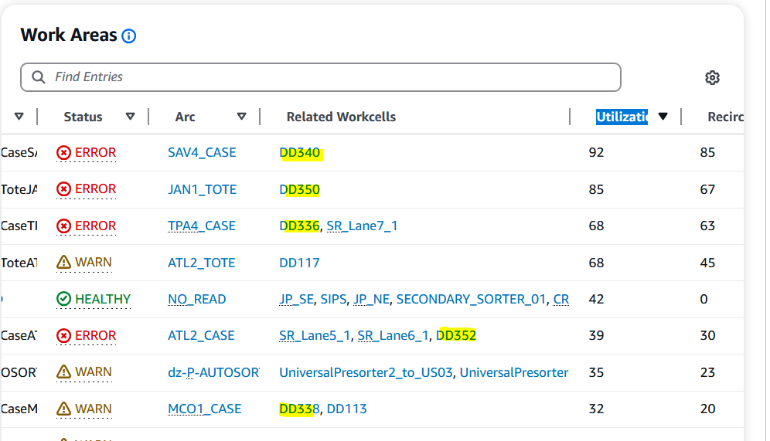
Figure 1: Example of one side of FL having significantly more top recirc

It is recommended that every leader in FL avoid bunching in one area for any length of time outside of syncs scheduled by AMs and OMs. Bunching opens leaders up to coverage gaps on the floors, which leads to slower reaction time, and more recirc.
While PAs or any Outbound leaders are walking through FL, they should follow a “See something, say something” protocol for the following events:
- Associates bunching in any location – identify if this is self-assignment, at a minimum the associates should be relocated to another department/door/area where they will provide value add (walk lines on the same side first to check for obvious, fast relocation opportunities, then reach out to the other side, then escalate to AM to send to a different department).
- Any line that is full – first check associate rate (see the next section, “DockFlow Outbound Page”), then assess if headcount can resolve the backup, then if that is insufficient reach out to Flow with the information just gathered to request a split. Splits should not occur if the headcount has not been confirmed to be at least two and diverts are not exceeding 75 per 15 minutes (this only requires associates stack 2.5 boxes per minute to keep up).
- Any line that is empty with 1 or more associates – for doors with empty lines and zero missed diverts, at most the headcount should be one fluid load associate, and if this is happening to more than one line, it is even better to have associates float between more than one nearby door if they are carefully managed.
- Blue lights anywhere when capacity to move.
In an ideal world, PAs will almost never have to check DockFlow because they will manage the visual indicators so closely, they will see lanes getting backed up physically before they utilize carriers. However, there is a very useful view in DockFlow for determining associate rate.
DockFlow Outbound Page
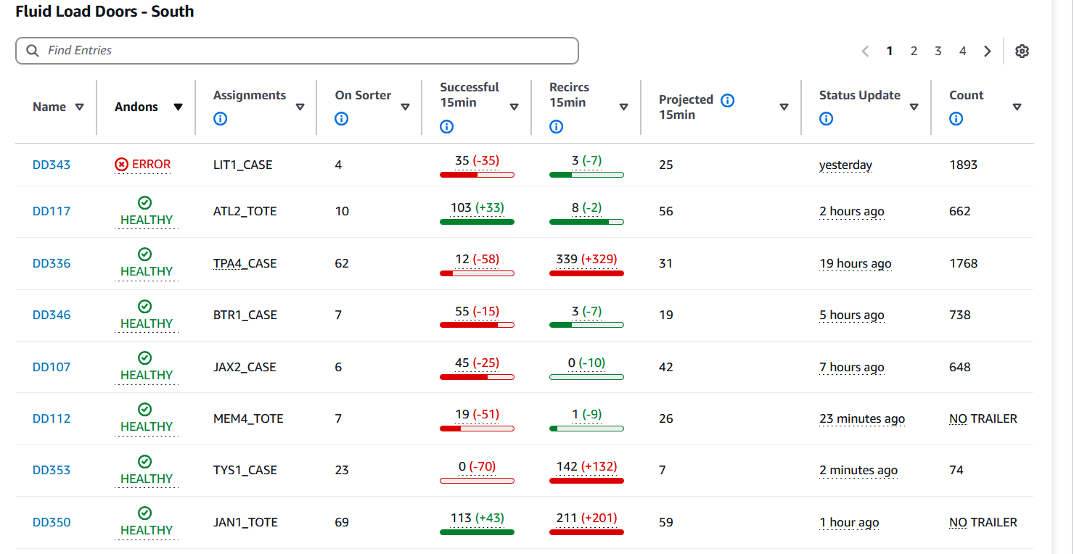
Figure 2: DockFlow Outbound Page
One of the barriers to being successful in Fluid Load is that Wall Builders are indirect, so they don’t have rates in PPR to coach. For PAs reading this doc, understand the “Successful 15min” column will be the easiest way to calculate an associate’s rate, and is a perfect starting point for digesting the DockFlow Outbound Page for beginners.
The number indicated in black under this column indicates how much work was diverted to each dock door in the last 15 minutes. In this example, if two associates were in DD336, and the line was clearly full, that would be concerning because only 12 diverts hit that line in the last 15 minutes. Once again, until the successful diverts number hits 75, a split should not be necessary.
Let’s break down the other columns:
- Andons – AMs and OMs should be hovering over anything that isn’t saying “Healthy” to understand the root cause and doing whatever they can to address what DockFlow is trying to tell them.
- Assignments – This could be useful if a split needs to be made here and the door is a hybrid, though that should be visible on the floor as well.
- On Sorter – This is a great way to prioritize which problems to address first. This indicates how many carriers are being occupied and trying to divert to that location. The more carriers taken by FL, the less room the building has to flow, so address this quickly.
- Recircs 15 min – This is related to “On Sorter”. More directly, it answers the question of whether or not the associates on that line (if there are any) are keeping up with the work. DockFlow will suggest this number remain <10. For AMs and OMs tracking to higher-level metrics, this will indicate which lanes are impacting Ops Recirc %.
Use the arrows at the tops of the columns to sort by the different factors and check for things like “Top Reicrc”, “Lowest Volume”, etc.
Key Takeaways
On a developed team, the PAs should be mostly focused on the physical indicators on the floor, but should still be referencing the DockFlow Outbound page around once per half hour to assess rates and catch other intangibles. PAs should avoid getting stuck in one place for more than 10 minutes at time without notifying an AM.
coming from the DockFlow.
If OMs are having to action observations in DockFlow or on the floor, this should be a coaching point for the team.

